Additional Notes

Machine Learning:

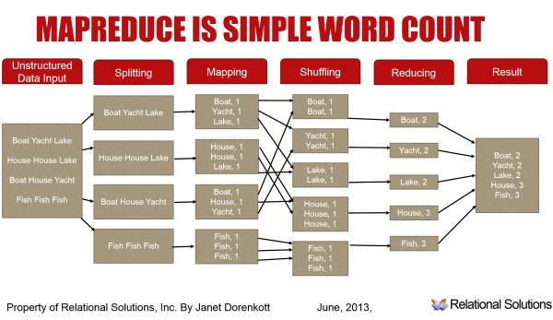
In machine learning and statistics, classification is the problem of identifying to which of a set of categories (sub-populations) a new observation belongs, on the basis of a training set of data containing observations (or instances) whose category membership is known. An example would be assigning a given email into "spam" or "non-spam" classes or assigning a diagnosis to a given patient as described by observed characteristics of the patient (gender, blood pressure, presence or absence of certain symptoms, etc.). Classification is an example of pattern recognition.
In the terminology of machine learning,[1] classification is considered an instance of supervised learning, i.e. learning where a training set of correctly identified observations is available. The corresponding unsupervised procedure is known as clustering, and involves grouping data into categories based on some measure of inherent similarity or distance.
Often, the individual observations are analyzed into a set of quantifiable properties, known variously as explanatory variables or features. These properties may variously be categorical (e.g. "A", "B", "AB" or "O", for blood type), ordinal (e.g. "large", "medium" or "small"), integer-valued (e.g. the number of occurrences of a particular word in an email) or real-valued (e.g. a measurement of blood pressure). Other classifiers work by comparing observations to previous observations by means of a similarity or distance function.
An algorithm that implements classification, especially in a concrete implementation, is known as a classifier. The term "classifier" sometimes also refers to the mathematical function, implemented by a classification algorithm, that maps input data to a category.
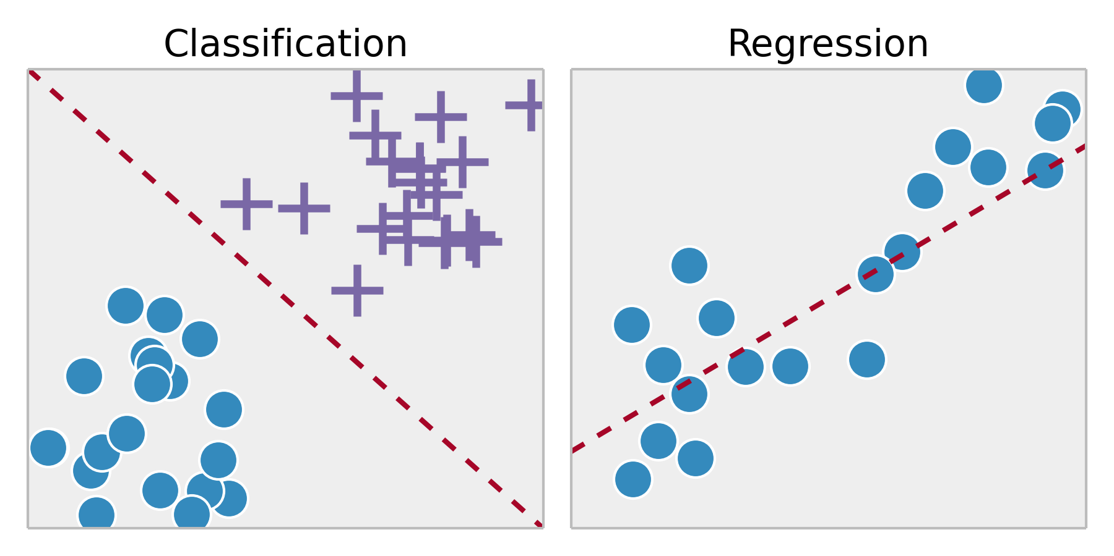
Regression involves estimating or predicting a response. Classification is identifying group membership.
Regression and classification are both related to prediction, where regression predicts a value from a continuous set, whereas classification predicts the 'belonging' to the class.
eg : price of a house depending on the 'size' (sq. feet or whatever unit) and say 'location' of the house, can be some 'numerical value' (which can be continuous) : this relates to regression.
Similarly the prediction of price can be in words, viz., 'very costly', 'costly', 'affordable', 'cheap', and 'very cheap' : this relates to classification.
Neural networks can be used only with numerical variables
Variables in a decision tree are usually represented by circles.

Explanation of decision tree
A decision tree is a set of rules used to classify data into categories. It looks at the variables in a data set, determines which are most important, and then comes up with a, well, tree of decisions which best partitions the data. The tree is created by splitting data up by variables and then counting to see how many are in each bucket after each split.
The key idea is that the procedure to create decision trees is recursive. For a set (S) of observations, the following algorithm is applied:
- If every observation in S is the same class or if S is very small, the tree becomes an endpoint, labeled with the most frequent class.
- If S is too large and it contains more than one class, find the best* rule based on one feature (e.g., "is weight > 150?") to split it into subsets, one for each class.
If you had to go to step 2, apply step 1 to each new subset. If your subsets need to go to step 2, apply step 1 to the sub-subsets, etc. When everything is split up appropriately (into buckets that are very small or entirely one class), you have a set of rules that look like a tree.**

Here's a minimum example. Given only the gender and weight of a person, can we predict whether they are Japanese or American?
If this is the training set:
Name/Weight (lbs.)/Sex/Nationality
Larry 195 M American
Jerry 190 M American
Carrie 160 F American
Cheri 165 F American
Yoshi 165 M Japanese
Yasuo 160 M Japanese
Michiko 130 F Japanese
Noriko 140 F Japanese
... then a decision tree would look like this:
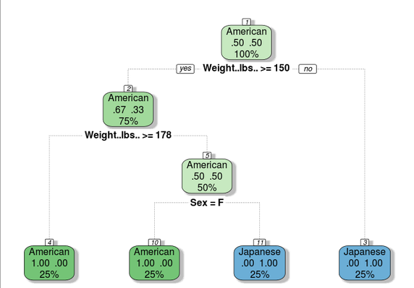
First, the model checks if a person is under 150 pounds. If so, they're classified as Japanese. If not, it sees if their weight is over 177 pounds. If so, they're American. If not, the last question asks whether it's a man or woman. With these three questions, you can use a person's sex and weight to predict what their nationality is. E.g., if you know a man is 200 pounds, the model predicts that he's American.
This example is convenient because the tree can perfectly explain the data--in the real world, there is overlap; there are fat Japanese people and skinny Americans. The model would be optimized to make the largest possible number of correct predictions, even though it can't be perfect.
(Note: decision trees are used for predicting continuous variables also, as opposed to categorical variables. It's easier to explain if I stick to categories.)
* The "best" branching rule is the one that results in the most information gain in most tree-generating algorithms.
** Trees are usually "pruned" to avoid overfitting. The pruning algorithm removes final nodes, based on misclassification rates, so that the model is a little more general.

